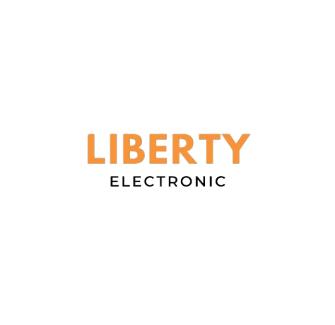

# TCL 32L5A 32 Inch Smart Android

• Android

• HDR

• Resolution

• Led Type

• Smart TV (Youtube, Internet Browsing e.t.c)

• 32 Inch